**SESQUICENTENARY (150th) ANNIVERSARY CELEBRATIONS**

**St Paul’s Seaforth Anglican Church**

**1875 – 2025**

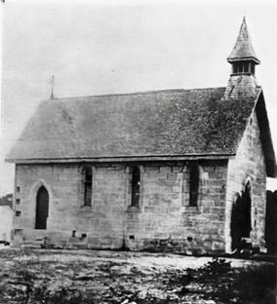

This building is the oldest in Seaforth and one of the oldest along the Northern Beaches.

As part of the Sesquicentenary Celebrations, the weekend of Friday 24th October to Sunday 26th October 2025 has been set aside to celebrate with a festival of varied activities for all members of our community to enjoy.

**OPEN DAY: Saturday 25th October 2025, 9am to 3pm.** Market stalls, historic displays, music, Devonshire teas, cake stall, sausage sizzle and kids’ activities.

**CREATIVE COMMUNITY COMPETITION:**

*In the early 1870s, the people of Middle Harbour (now known as Seaforth) decided they needed a local church and set about thinking about how they could do this. 150 years later, the church they built still stands but our community is very different… or is it? Just like the people of this area 150 years ago, let’s all think what is most needed in our community right now in 2025.*

***What do you think our community needs most in 2025 and beyond?***

**CATEGORIES:** 10 years and under **OR** 11- 17 years **OR**  18 years+

Create an artwork or write or use whatever medium you wish to answer this question and submit it to: The **2025 SEAFORTH COMMUNITY COMPETITION BOX** at the office of Seaforth Anglican Church, 3 Frenchs Forest Rd, Seaforth 2092 or email it to [office@seaforthanglican.org.au](mailto:office@seaforthanglican.org.au) by **5pm, Friday 17 October 2025.**

**JUDGES:** Local community leaders

**PRIZES:** Valuable vouchers from local restaurants and services, plus the opportunity to consider with local leaders how your ideas could become reality

**WINNERS ANNOUNCED:** Our Northern Beaches Council Mayor, Sue Heins will announce the winners at 12 noon at our Open Day on Saturday 25th October at the church entrance.

Enquiries to Event coordinator, Jill at [jillwr@gmail.com](mailto:jillwr@gmail.com) or 0413 605 289